**INVENTORY DATABASE MANAGEMENT SYSTEM**

**ABSTRACT:**

An inventory management system is the combination of technology (hardware and software) and processes and procedures that oversee the monitoring and maintenance of stocked products, whether those products are company assets, raw materials and supplies, or finished products ready to be sent to vendors or end consumers.

This system can widely be used by normal shops, departmental stores or MNCs for keeping a proper track of the stock. It also consists of information like manager details, customer details etc. With the help of this system we can fix a minimum quantity of any inventory below which we need to place an order for that inventory. This will help us in good sales results and never the out of stock stage for any inventory.

**Problem statement:**

The problem lies in the inability to maintain accurate records of inventory levels, leading to issues such as overstocking, stockouts, and inventory shrinkage. These challenges can result in increased operational costs, lost sales opportunities, and decreased customer satisfaction. Additionally, the manual processes often employed are prone to human error, which further complicates inventory management.

The need is for an automated, real-time system that can streamline inventory processes, provide accurate and timely data, and integrate with other business operations to optimize stock levels, reduce waste, and improve overall efficiency. This system should also provide analytics and reporting tools to assist in decision-making and forecasting future inventory needs.

**ER DIAGRAM**

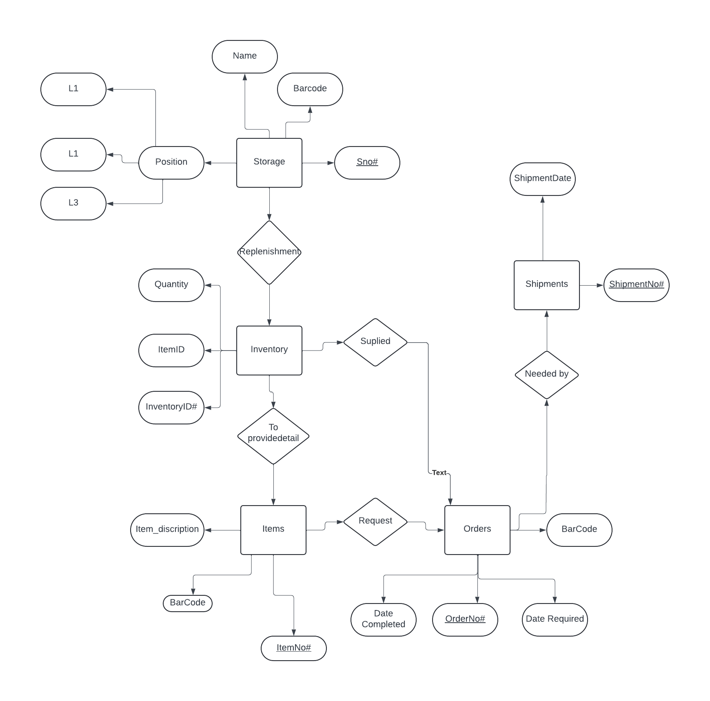

**SCHEMA**

CREATE TABLE Position (

PositionID INT PRIMARY KEY,

Name VARCHAR(255)

);

CREATE TABLE Storage (

StorageID INT PRIMARY KEY,

Name VARCHAR(255),

Barcode VARCHAR(255),

Sno INT

);

CREATE TABLE Inventory (

InventoryID INT PRIMARY KEY,

ItemID INT,

Quality VARCHAR(255),

ReplenishmentNeeded BOOLEAN,

Supplied BOOLEAN,

FOREIGN KEY (ItemID) REFERENCES Items(ItemID)

);

CREATE TABLE Items (

ItemID INT PRIMARY KEY,

ItemDescription VARCHAR(255),

Barcode VARCHAR(255),

ItemNO INT

);

CREATE TABLE Orders **(**

OrderID INT PRIMARY KEY,

Barcode VARCHAR(255),

DataCompleted BOOLEAN,

OrderNO INT,

DateRequired DATE,

ShipmentDate DATE

);

CREATE TABLE Shipments (

ShipmentID INT PRIMARY KEY,

OrderID INT,

ShipmentDate DATE,

ShipmentNO INT,

FOREIGN KEY (OrderID) REFERENCES Orders(OrderID)

);

**IMPLEMENTATION:**

**CREATE OPERATION:**

Create table Position (PositionID varchar(50) primary key,Name varchar(255));

**O/P:**

Table created.

Create table Storage (StorageID varchar(50) primary key,Name varchar(255),Barcode varchar(255),Sno int);

**O/P:**

Table created.

Create table Items (ItemID varchar(50) primary key,ItemDescription varchar(255),Barcode varchar(255),ItemNO int);

**O/P:**

Table created.

Create table Inventory (InventoryID varchar(50) primary key,ItemID int,Quality varchar(255),ReplenishmentNeeded varchar(50),Supplied varchar(50),foreign key(ItemID) references Items(ItemID));

**O/P:**

Table created.

Create table Orders (OrderID varchar(50) primary key,Barcode varchar(255),DataCompleted varchar(50),OrderNO int,DateRequired date,ShipmentDate date);

**O/P:**

Table created.

Create table Shipments(ShipmentID varchar(50) primary key,OrderID varchar(50),ShipmentDate date,ShipmentNO int,foreign key (OrderID) references Orders(OrderID));

**O/P:**

Table created.

**INSERT OPERATION:**

INSERT INTO Position VALUES('P01','Manager');

**O/P:**

1 row(s) inserted.

INSERT INTO Position VALUES('P02','Supervisor');

**O/P:**

1 row(s) inserted.

INSERT INTO Position VALUES('P03','Technician');

**O/P:**

1 row(s) inserted.

INSERT INTO Storage VALUES('S01','Main Storage','ABC123',1001);

**O/P:**

1 row(s) inserted.

INSERT INTO Storage VALUES('S02','Overflow Storage','XYZ456', 1002);

**O/P:**

1 row(s) inserted.

INSERT INTO Storage VALUES('S03','Cold Storage','CDE789', 1003);

**O/P:**

1 row(s) inserted.

INSERT INTO Items VALUES('I01','Laptop', 'LAP123', 2001);

**O/P:**

1 row(s) inserted.

INSERT INTO Items VALUES('I02','Keyboard', 'KEY456', 2002);

**O/P:**

1 row(s) inserted.

INSERT INTO Items VALUES('I03','Mouse', 'MOU789', 2003);

**O/P:**

1 row(s) inserted.

INSERT INTO Inventory VALUES(1, 'I01', 'Good', 'No', 'Yes');

**O/P:**

1 row(s) inserted.

INSERT INTO Inventory VALUES(2, 'I02', 'Excellent', 'No', 'Yes');

**O/P:**

1 row(s) inserted.

INSERT INTO Inventory VALUES(3, 'I03', 'Average', 'Yes', 'No');

**O/P:**

1 row(s) inserted.

INSERT INTO Orders VALUES ('O01','LAP123','Yes',3001,TO_DATE('2024-10-01','YYYY-MM-DD'),TO_DATE('2024-10-05', 'YYYY-MM-DD'));

**O/P:**

1 row(s) inserted.

INSERT INTO Orders VALUES ('O02','KEY456','No',3002, TO_DATE('2024-10-10', 'YYYY-MM-DD'),TO_DATE('2024-10-15', 'YYYY-MM-DD'));

**O/P:**

1 row(s) inserted.

INSERT INTO Orders VALUES ('O03', 'MOU789', 'Yes',3003,TO_DATE('2024-10-12', 'YYYY-MM-DD'),TO_DATE('2024-10-17', 'YYYY-MM-DD'));

**O/P:**

1 row(s) inserted.

INSERT INTO Shipments VALUES('SH1','O01',TO_DATE('2024-10-05', 'YYYY-MM-DD'),4001);

**O/P:**

1 row(s) inserted.

INSERT INTO Shipments VALUES('SH2','O02',TO_DATE('2024-10-17', 'YYYY-MM-DD'),4002);

**O/P:**

1 row(s) inserted.

INSERT INTO Shipments VALUES('SH3','O03',TO_DATE('2024-10-17', 'YYYY-MM-DD'), 4003);

**O/P:**

1 row(s) inserted.

**DESCRIBE OPERATION:**

Desc items;

**O/P:**

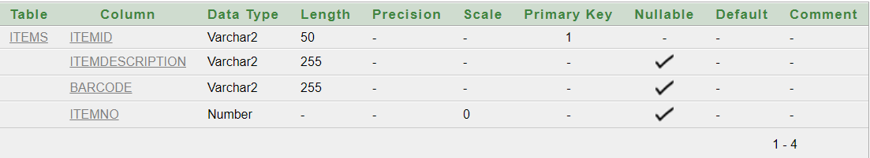

**SELECT OPERATION:**

select * from position;

**O/P:**

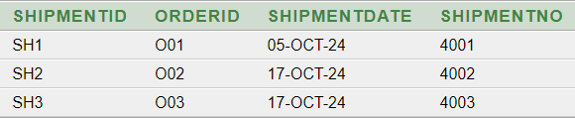

**UPDATE OPERATION:**

UPDATE Inventory SET Quality = 'Poor' WHERE ItemID = 'I01';

**O/P:**

1 row(s) updated.

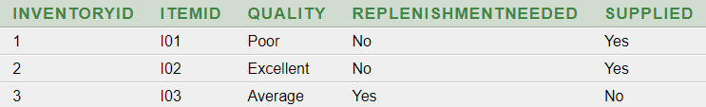

**DELETE OPERATION:**

DELETE FROM Shipments WHERE ShipmentID = 'SH1';

**O/P:**

1 row(s) deleted.

**ALTER OPERATION:**

ALTER TABLE Inventory DROP COLUMN ReplenishmentNeeded;

**O/P:**

Table altered.

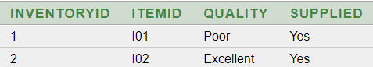

**MODIFY OPERATION:**

ALTER TABLE Storage MODIFY Name VARCHAR(500);

**O/P:**

Table altered.

**RENAME OPERATION:**

RENAME Storage TO Warehouse;

O/P:

Statement processed.

**DROP OPERATION:**

Drop table warehouse;

**O/P:**

Table dropped.